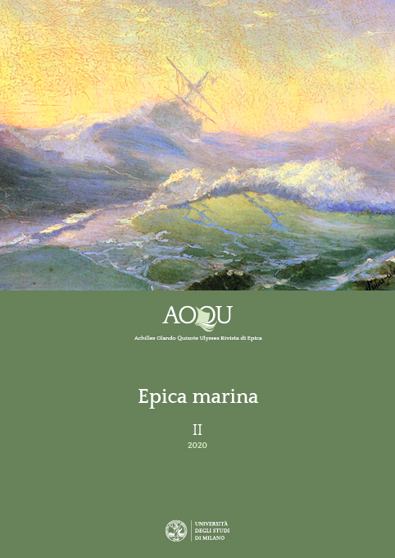***Call for Papers: Epics and the Sea***

|  |
| --- |
| Epics, in its common usage, is intrinsically linked to battles, sieges, duels of great heroes, victorious or desperate charges. In short, the entire tradition of the genre has always been grounded in the land since the Iliad; yet the Odyssey opens a completely different territory to the epic world: waters, seas and oceans.  «AOQU» Journal welcomes essays – in Italian, English, French or Spanish – on Marine Epics in various literatures, ages and forms, not exclusively literary forms. “Epics on the sea” has to be intended as a story of great sea-battles and voyages, monsters and undersea worlds, symbols and metaphors: different spaces, characters, plots and paradigms. Texts, episodes and forms dealing with whatever kind of pond or water flow, as lakes and rivers, can be also considered.  The monographic issue *Epics and the Sea* is due in late Autumn 2020. The deadline for submissions to [aoqu@unimi.it](mailto:aoqu@unimi.it) is March 15th (abstracts should not exceed 1.500 characters); the staff will communicate the acceptance of the proposal by April 15th. Essays should be sent by September 30th. |

ᴥ ᴥ ᴥ ᴥ ᴥ

The Journal «AOQU. Achilles Orlando Quixote Ulysses» aims to be a place for scholars from multiple disciplines to discuss on Epics (as a genre proper, or as a register) beyond languages, cultures, ages, forms (e.g. movies and comics). Epic poetry will be considered as a cultural, moral and ideological model, defining self-perception in history and society, in relationship with other cultures, ideologies as well as imagination.

The Journal is biannual, and the first issue will be published in late Spring 2020. It will be Open Access on OJS 3 platform within a project fostered by the Faculty of Studi umanistici (Humanities) of University of Milan.

<https://riviste.unimi.it/index.php>